Project Design Phase-II
Data Flow Diagram & User Stories

Date | 5/July/2026
Team ID
Project Name | Book A Doctor
Maximum Marks | 4 Marks

Data Flow Diagrams:
A Data Flow Diagram (DFD) is a traditional visual representation of the information flows within a system. A neat and clear DFD can depict the right amount of the system requirement graphically. It shows how data enters and leaves the system, what changes the information, and where data is stored.
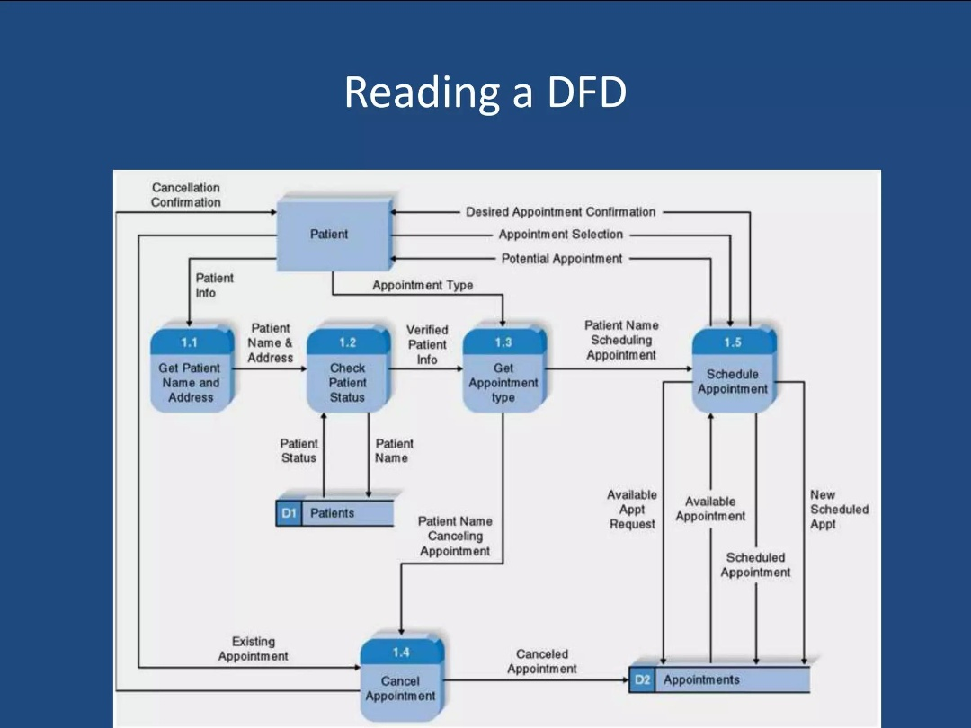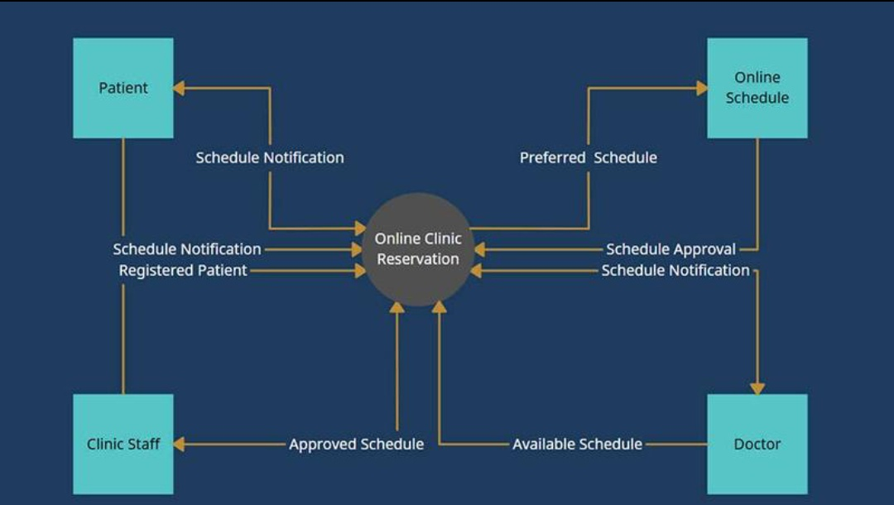

User Stories
Use the below template to list all the user stories for the product.
User Type | Functional Requirement (Epic) | User Story Number | User Story / Task | Acceptance criteria | Priority | Release
Patient | User registration | USN-1 | As a patient, I want to register so that I can book appointments | User can register with valid email & password and data is stored in DB | High | Release-1
Patient | User login | USN-2 | As a patient, I want to login securely | User should login using correct credentials and receive JWT token | High | Release-1
Doctor | Doctor registration | USN-3 | As a doctor, I want to create my profile  High  Release 1 | Doctor profile is saved with specialization and availability | High | Release-1
Admin | User management | USN-4 | As an admin, I want to manage users | Admin can view, add, or remove users from system | High | Release-1
Patient | Doctor search | USN-5 | As a patient, I want to search doctors  Medium  Release 2 | Search results should filter by name, specialization, location | Medium | Release-2
Patient | View doctor profile | USN-6 | As a patient, I want to view doctor details | Doctor profile shows experience, availability, fees | Medium | Release-2
Doctor | Appointment management | USN-7 | As a patient, I want to book an appointment | Appointment gets removed and slot becomes available | High | Release-2
Patient | Cancel appointment | USN-8 | As a doctor, I want to view appointments | Doctor can see all upcoming appointments | High | Release-2
Doctor | Dashboard | USN-9 | As a patient, I want to cancel appointment | Appointment gets removed and slot becomes available | Medium | Release-3
Admin | Reports | USN-10 | As a doctor, I want a dashboard | Dashboard shows today's appointments and schedule | High | Release-3
system | notifications | USN-11 | As an admin, I want reports | System generates appointment and user reports | Medium | Release-3

